Cargue imagen

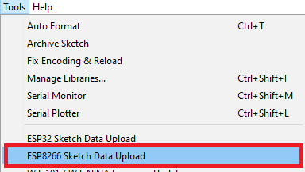

Segun si usa ESP32 o ESP8266 se escoje para cargar los archivos

#include "FS.h"  
  
void setup()  
{  
  Serial.begin(115200);  
  SPIFFS.begin();  
  Dir dir = SPIFFS.openDir("/");  
  while (dir.next())  
  {  
    fileName = dir.fileName();  
    Serial.print(dir.fileName());  
  }  
}

#include <FS.h>

#include "SPIFFS.h" // ESP32 only

// JPEG decoder library

#include <JPEGDecoder.h>

#include <TFT_eSPI.h> // Hardware-specific library

TFT_eSPI tft = TFT_eSPI(); // Invoke custom library

void setup()

{

Serial.begin(250000);

delay(10);

tft.begin();

tft.setRotation(0); // 0 & 2 Portrait. 1 & 3 landscape

tft.fillScreen(TFT_BLACK);

if (!SPIFFS.begin()) {

Serial.println("SPIFFS initialisation failed!");

while (1) yield(); // Stay here twiddling thumbs waiting

}

listFiles(); // Lists the files so you can see what is in the SPIFFS

}

void loop()

{

// Note the / before the SPIFFS file name must be present, this means the file is in

// the root directory of the SPIFFS, e.g. "/tiger.jpg" for a file called "tiger.jpg"

tft.setRotation(0); // portrait

tft.fillScreen(random(0xFFFF));

drawJpeg("/tiger.jpg", 0 , 0); // 240 x 320 image

delay(2000);

}

|  |
| --- |
| #define FS_NO_GLOBALS |